
HOW TO USE TERMINAL TO PRINT DEBUG INFO IN MCUXPRESSO
Advanced Embedded Systems

Authors: Dr. Gilberto Ochoa Ruiz
Msc. Jorge German Perez Blanco
Contents
Introduction 3
Enable Terminal to stream data from UART 3
Annexes 6
Example application code 6
Pit.c 6

Introduction
Code debugging is a fundamental aspect of software development, playing a crucial role in identifying and rectifying errors within the code. These errors can encompass a range of issues, from basic syntax errors to more complex logical errors that result in unexpected behaviors. Debugging tools empower developers to systematically analyze their code, inspect variables, and comprehend the flow of execution, facilitating the precise location and correction of bugs. The impact of debugging extends to performance optimization. Bugs in code can negatively impact an application's performance, leading to bottlenecks. Debugging aids in identifying and optimizing problematic code sections, contributing to a faster and more efficient software experience for users.
Debugging is of paramount importance in the realm of embedded systems due to the unique challenges associated with these specialized computing environments. Embedded systems often operate in real-time scenarios, where precise and timely responses are critical for proper functionality. Debugging in this context ensures that the code meets stringent real-time constraints, allowing embedded systems to perform as expected within predefined time frames. Another significant factor in embedded systems is the constraint on resources such as memory, processing power, and energy. Debugging plays a pivotal role in optimizing code for efficient resource utilization. It helps identify and rectify issues like memory leaks, minimizes processing overhead, and ensures that the embedded system operates within its resource limitations. Embedded systems closely interact with hardware components, and debugging becomes essential for ensuring proper communication and synchronization between the software and hardware. Issues related to interrupts, I/O operations, and hardware interfaces can be identified and addressed through effective debugging processes. Unlike traditional computing environments, many embedded systems operate without direct user interfaces. Debugging becomes the primary means for diagnosing issues, as developers may lack visual feedback or traditional user interfaces to detect problems. Debugging tools, logs, and diagnostic information become critical for understanding and resolving issues in such scenarios.
Ultimately, debugging ensures that software meets user expectations and specifications. Users anticipate applications that work seamlessly without errors, and the diligent practice of debugging is instrumental in achieving this goal. In summary, debugging is an indispensable and ongoing process that directly shapes the creation of reliable, high-quality, and efficient software applications.
In this particular guide, we will demonstrate how to use the Terminal to print debugging information. For more info on Debug check the “HOW TO DEBUG CODE IN MCUXPRESSO” guide.

Enable Terminal to stream data from UART
The first thing you need to make sure is that the terminal is enabled for UART transmission. In order to do enable it, in the SDK Wizard window, on the second screen, after selecting the card, you need to tick the appropriate SDK Debug Console option, as shown in the next screen.
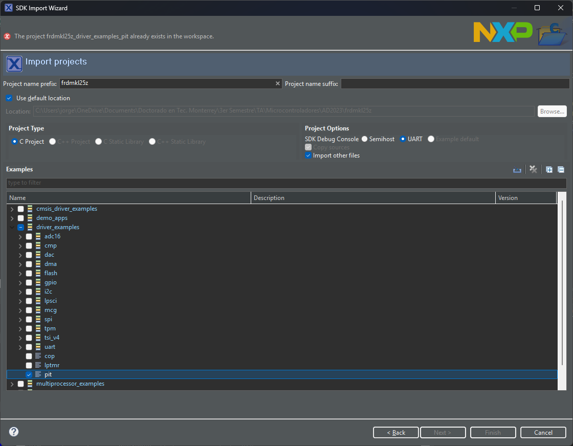

The Terminal window
The Terminal window is located in the bottom center of the screen in the default Developer Perspective view. You need to click on Terminal tab to see it.
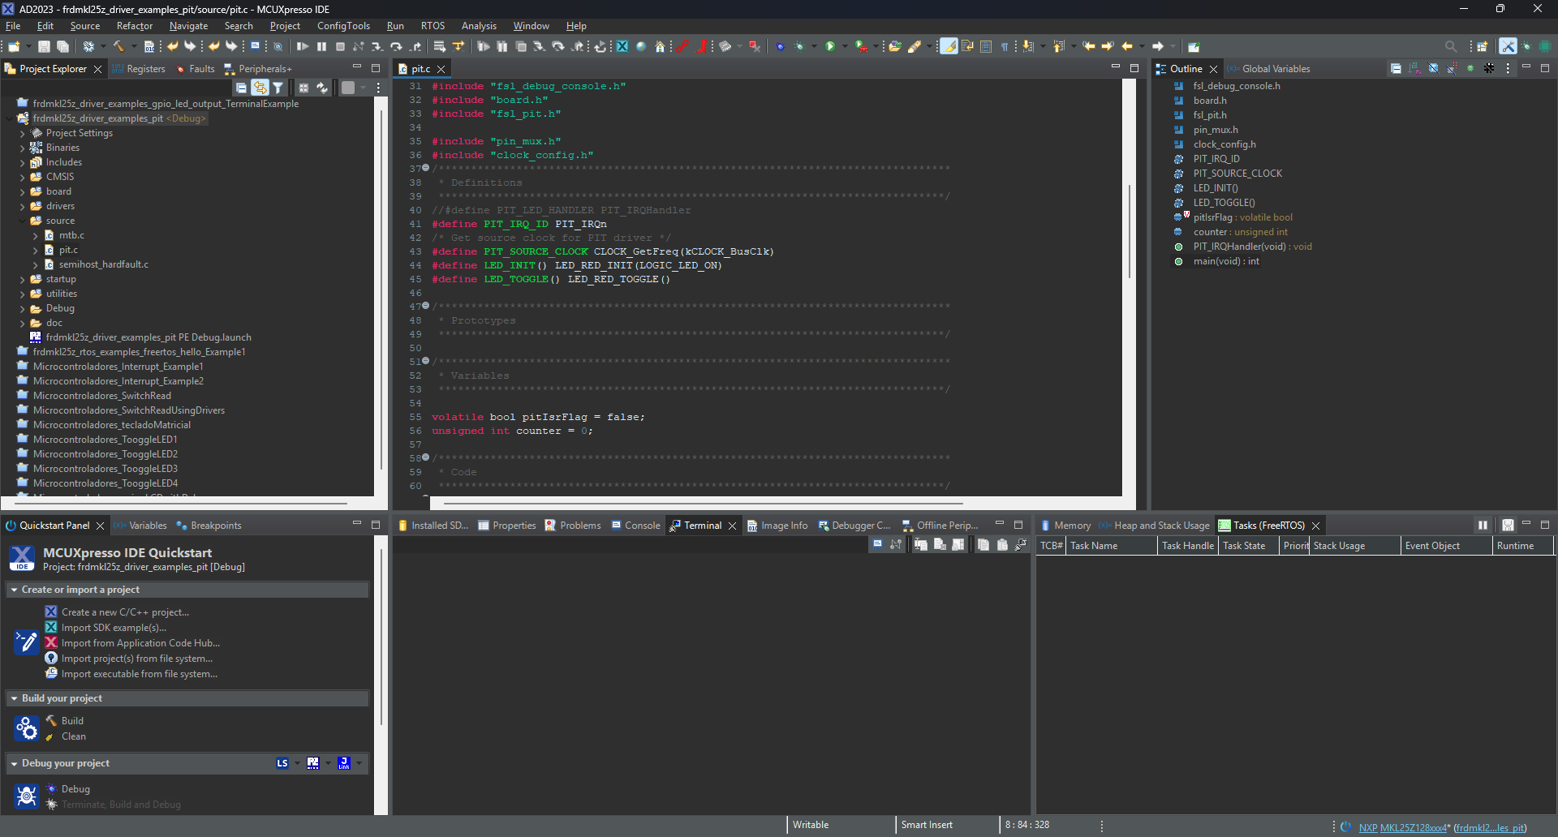
To open the terminal and stablish the UART connection you need to click on the icon that has a monitor, shown in the previous picture.
Once you click on the Open Terminal button, the Lauch Terminal window will appear with all the connection parameters, you must leave all of them by default. Also make sure you have the board connected to your pc. Click the Ok button and the connection is opened, and you will start receiving all the information that is sent from your board through the UART interface.
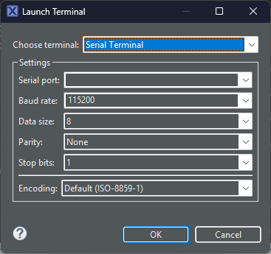
In the following picture you can see an example of the Terminal receiving data. The code can be checked on the annexes.
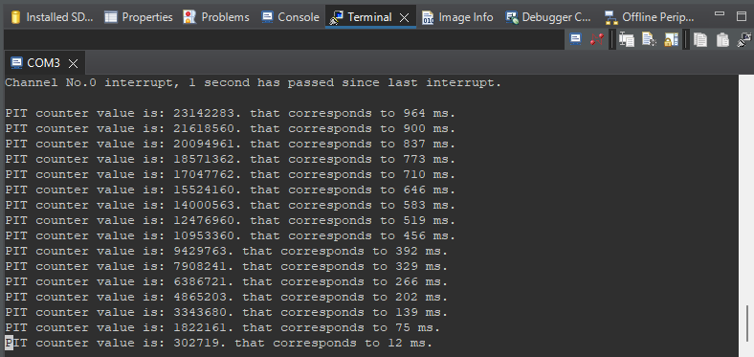
Making use of the other buttons in the Terminal window, you can close connection, clear terminal content, send data among other options.
How to send through Terminal
If you enabled the stream of data from UART as explained in the first section, then you just need to use the PRINTF() build-in function in your code to start sending data. You can send string to the user, with variables of different types, as in the standard printf() c function. You can use this function whenever you need to print debug information (peripheral and processor registers, local and global variables, etc) without actually entering in the debug mode, of course with some limitations, you will not be able to run code step by step but this method of printing the info through the terminal might be helpful I some cases. A simple code exemplifying this functionality is presented in the annexes.

Annexes

Example application code

Pit.c
#include "fsl_debug_console.h"
#include "board.h"
#include "fsl_pit.h"

#include "pin_mux.h"
#include "clock_config.h"
/*******************************************************************************
* Definitions
******************************************************************************/
//#define PIT_LED_HANDLER PIT_IRQHandler
#define PIT_IRQ_ID PIT_IRQn
/* Get source clock for PIT driver */
#define PIT_SOURCE_CLOCK CLOCK_GetFreq(kCLOCK_BusClk)
#define LED_INIT() LED_RED_INIT(LOGIC_LED_ON)
#define LED_TOGGLE() LED_RED_TOGGLE()

/*******************************************************************************
* Variables
******************************************************************************/

volatile bool pitIsrFlag = false;
unsigned int counter = 0;

/*******************************************************************************
* Code
******************************************************************************/
void PIT_IRQHandler(void)
{
/* Clear interrupt flag.*/
PIT_ClearStatusFlags(PIT, kPIT_Chnl_0, kPIT_TimerFlag);
pitIsrFlag = true;
}

/*!
* @brief Main function
*/
int main(void)
{
/* Structure of initialize PIT */
pit_config_t pitConfig;

/* Initialize and enable LED */
LED_INIT();

/* Board pin, clock, debug console init */
BOARD_InitPins();
BOARD_BootClockRUN();
BOARD_InitDebugConsole();

/*
* pitConfig.enableRunInDebug = false;
*/
PIT_GetDefaultConfig(&pitConfig);

/* Init pit module */
PIT_Init(PIT, &pitConfig);

/* Set timer period for channel 0 */
PIT_SetTimerPeriod(PIT, kPIT_Chnl_0, USEC_TO_COUNT(1000000U, PIT_SOURCE_CLOCK));

/* Enable timer interrupts for channel 0 */
PIT_EnableInterrupts(PIT, kPIT_Chnl_0, kPIT_TimerInterruptEnable);

/* Enable at the NVIC */
EnableIRQ(PIT_IRQ_ID);

/* Start channel 0 */
PRINTF("\r\nStarting channel No.0 ...\r\n");
PIT_StartTimer(PIT, kPIT_Chnl_0);

PRINTF("The input timer frequency is %d Hz.\r\n\n", PIT_SOURCE_CLOCK);

while (true)
{
if(counter == 100000)
{
uint32_t countValue = PIT_GetCurrentTimerCount(PIT, kPIT_Chnl_0);
PRINTF("PIT counter value is: %d. that corresponds to %d ms.\r\n", countValue, COUNT_TO_MSEC(countValue, PIT_SOURCE_CLOCK));
counter = 0;
}

/* Check whether occur interupt and toggle LED */
if (true == pitIsrFlag)
{
PRINTF("\r\nChannel No.0 interrupt, 1 second has passed since last interrupt.\r\n\n");
LED_TOGGLE();
pitIsrFlag = false;
}

counter ++;
}
}

